**EXPERIMENT 1**

ER DIAGRAM OF COLLEGE DATABASE

**Aim:** Draw an ER diagram of a college database.

ER Diagram of College Database

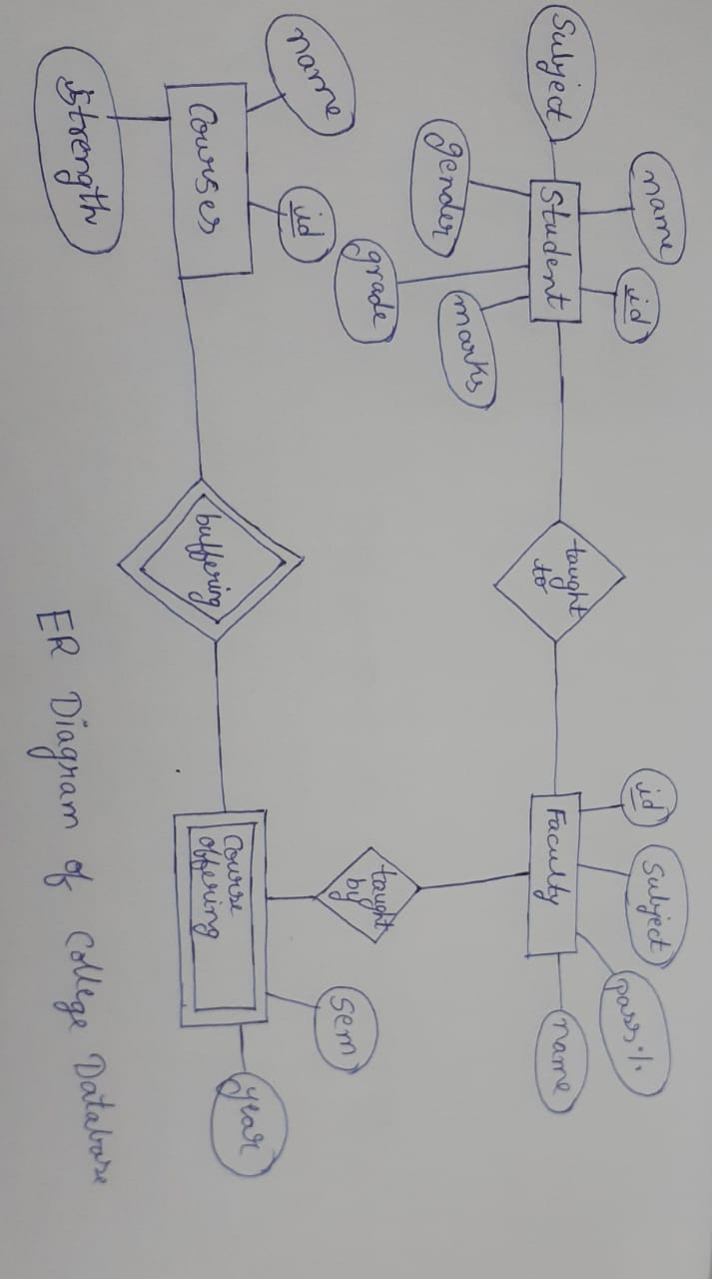

**Components of an ER diagram:**

* **Entity :**  An entity can be a person, place, event, or object that is relevant to a given system.represented by a rectangle .
* **Attribute :** An attribute is a property, trait, or characteristic of an entity, relationship, or another attribute.Represented by oval shapes.
* **Weak entity :** A weak entity is an entity that depends on the existence of another entity.Represented by a double rectangle.

* **Multivalued Attribute :** If an attribute can have more than one value it is called a multivalued attribute.Represented by double ovals.
* **Derived attribute :** An attribute based on another attribute.Represented by dotted ovals.
* **Relationship :** A relationship describes how entities interact.Represented by diamond shape.